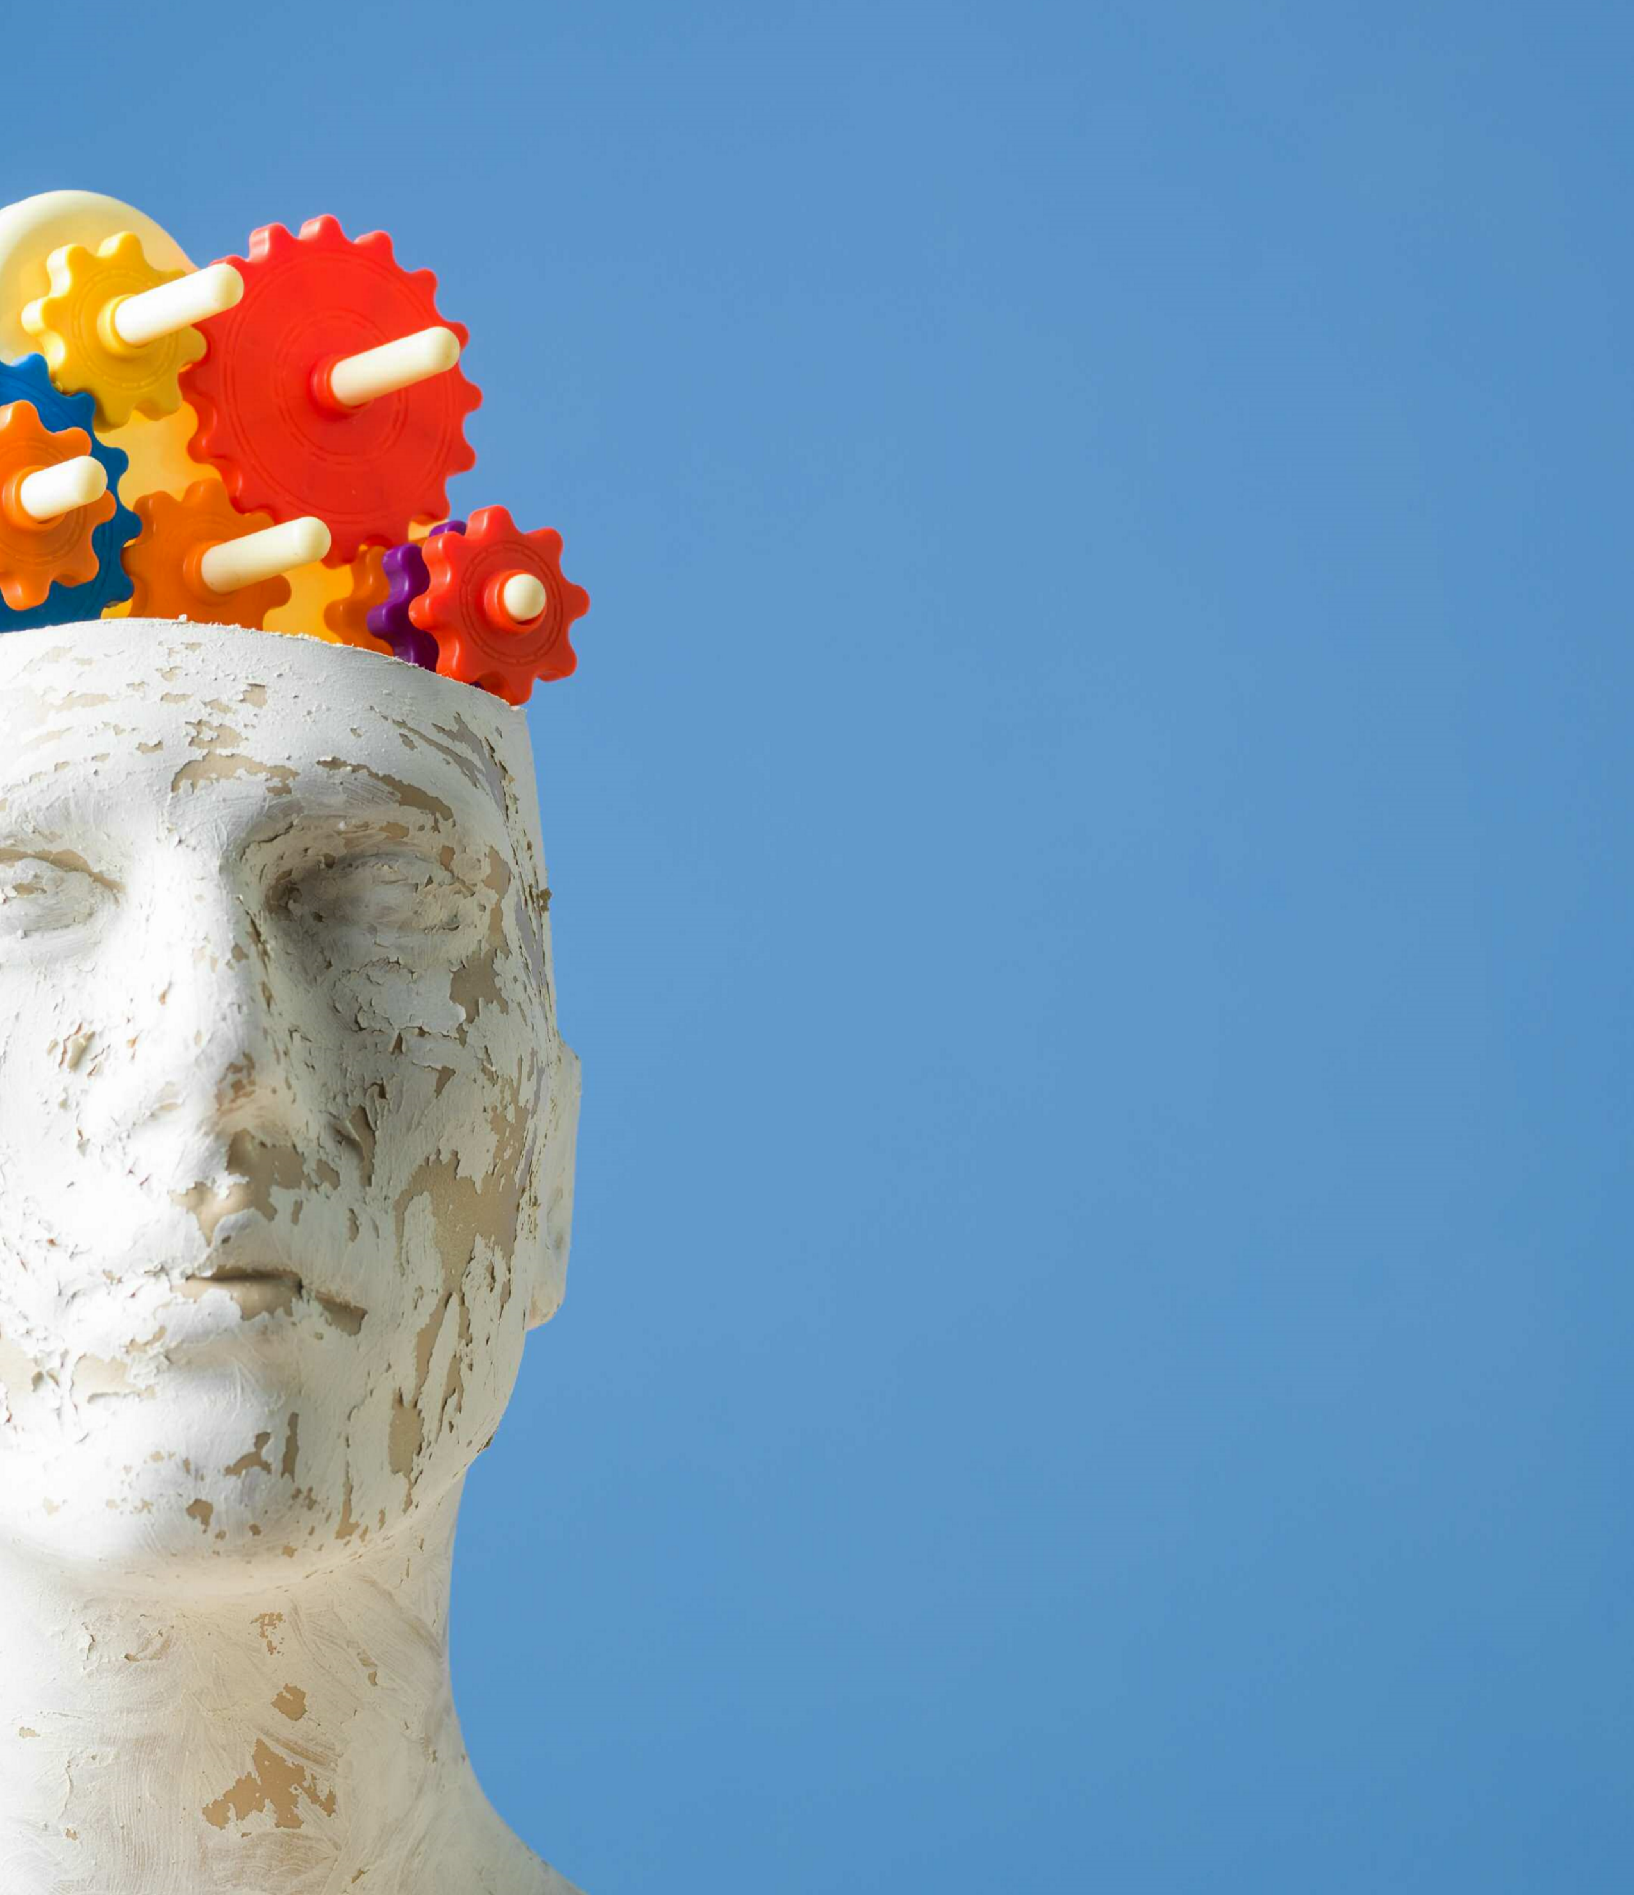

**Save the Date**

**September 9,**

**2019**

**• 6:30**

**PM**

**–**

**9:00**

**PM**

**Effects of Addictive**

**Substances on the Brain**

**Also Available this Evening:**

**• Narcan Training**

**• Drug Testing Kits**

**• Medicine Take-Back**

**• Drug Disposal KITs**

**• Educational Materials**

Light Refreshments Served

Sponsored by the Smithtown Rotary and provided by WellLife Network

and the Town of Smithtown Horizons Counseling and Education Center.

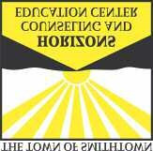

**Join Us**

**for a**

**Free Seminar**

**Open to Community Members,**

**their Families and Professionals**

**presented by**

**Dr. Stephen Dewey**

**Neuroscientist**

**To be held at**

**Smithtown Landing and Country Club**

**495**

**Landing Avenue**

**Smithtown, NY**

**11787**

**Smithtown, New York**

**T**

**h**

**e**

**R**

**o**

**t**

**a**

**r**

**y**

**C**

**l**

**u**

**b**

**o**

**f**

**S**

**m**

**i**

**t**

**h**

**t**

**o**

**w**

**n**