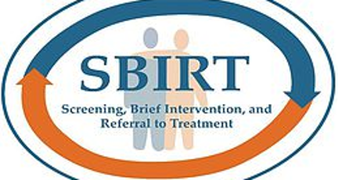
The SCCC Chemical Dependency Counselor Training Program is providing SBRIT trainings on the Brentwood campus.

Friday July 26th 2019
9:00AM – 1:00PM
Paumanok Hall 116

XSA100 SBIRT – Screening Brief Intervention Referral to Treatment CRN# 65165 Tuition $59.00
This four-hour training will be conducted by Kathleen Ayers-Lanzillotta, SCCC Allied Health Chair & Chemical Dependency Counseling Program Coordinator. The training will provide participants with the knowledge and ability to implement SBIRT. The training is a comprehensive, integrated, public health approach to the delivery of early intervention and treatment services for persons with substance use disorders, as well as those who are at risk of developing these disorders. The training focuses on screening procedures to identify risks; key motivational interviewing concepts and brief intervention; and referral to treatment for people with more serious alcohol and other drug use-related problems.
Upon successful completion participants will receive a Certificate from New York State Office of Alcoholism and Substance Abuse Services. This course will also count as four CASAC hours.

To register, complete the bottom portion of this form and deliver to:
SCCC Grant/Brentwood Campus Registrar Office-Caumsett Hall rm. H113
1001 Crooked Hill Road Brentwood, NY 11717
Phone: (631) 851-6780 with payment of $59

Registration must be complete ASAP to ensure a seat in the class.

Training is for anyone working in the Health & Human Services Delivery System

You may call the Office for Continuing Education at 631-451-4114 if you have any questions or concerns.
REFUND POLICY: Since all courses are on a first-come, first served basis, we encourage you to apply early. If a course should be canceled due to insufficient enrollment, you will be notified by the Registrar’s Office and you will have a check issued as promptly as possible. Non-credit courses will be refunded at the same percentage rate as that used for credit courses. If you have any questions on these policies or refund dates, please feel free to ask for clarification in the campus Business Office.
- - - - - - - - - - - - - - - - -
CRN# 65165 | Screening Brief Intervention Referral to Treatment
SCCC ID (if applicable) | Last Name First Name Middle Initial
Home Address City State Zip Code
Date of Birth |  | Home Telephone # | Cell Phone #
E-Mail Address

