**Virtual Overdose Prevention with Naloxone/Narcan Training**

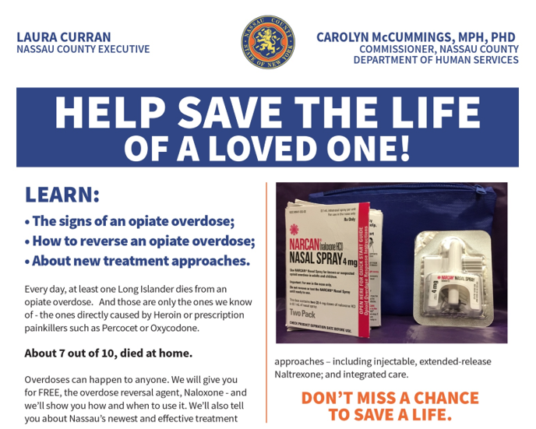**THURSDAY, DECEMBER 3, 2020**

**From 11:00am To 12:30pm**

**This will be a virtual training through ZOOM.**

**Please RSVP by November 19, 2020 via:**

[**www.nassaucountyny.gov/overdosetraining**](http://www.nassaucountyny.gov/overdosetraining)

[REGISTER](https://forms.nassaucountyny.gov/agencies/CE/narcan/ontraining.php)**Event Capacity is Fifty and registration will close once maximum capacity is reached.**

**Narcan Kits will be available for Contactless pick up**

**@ 60 Charles Lindbergh Blvd, Uniondale, NY 11553 on**

**Monday December 7 between 2-4pm**

[REGISTER](https://forms.nassaucountyny.gov/agencies/CE/narcan/ontraining.php)**and Wednesday December 9 between 10-12noon**

**Please log on timely.**

**We will be covering NYS mandated slides in order to receive a kit.**

