Friday June 11th 2021  Ethics in Prevention Training  What is the Ethics in Prevention training?  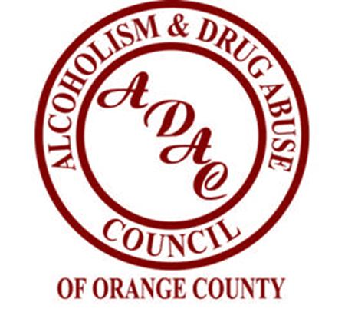  This is a 7-hour course of study in ethics in substance abuse prevention. It will be delivered via a virtual format. Training link will be provided with registration confirmation. Developed by the Substance Abuse and Mental Health Services Administration’s Center for the Application of Prevention Technologies for entry level and experienced prevention practitioners. This training covers the six principles of the Prevention Code of Ethics and utilizes a formalized ethical decision-making process.  Must attend the FULL day and pass the quiz to receive a certificate. 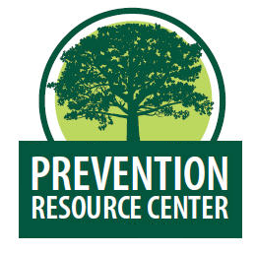 LONG ISLAND PRC  Funding for the Prevention Resource Centers is provided by the Office for Addiction Services and Supports | June 11th  9 am-4 pm  ────  Explore the role of ethics in your work.  ────  Assess and address a range of ethical issues.  ────  International Credentialing and Reciprocity Consortium (IC&RC) endorsed. OASAS Hours Approved  ────  Space is limited. Please register with  Jennifer Ocasio at jocasio@adacinfo.com  845-294-9000 x261  Pamela Mizzi at  info@liprc.org  631.650.0135  Location:  Zoom Link will be provided with registration confirmation.  845-294-9000

