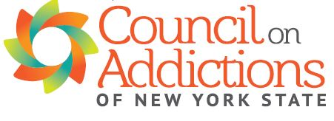
The NY State Marijuana Regulation and Taxation Act & Communities
A two-part webinar

Part I: The Impact of Retail Cannabis Sales On Communities
Monday, May 17th 9:00-11:00 AM

Matthew Leonardo, JD will describe the specific provisions of the NY State Marijuana Regulation and taxation Act regarding retail sales in dispensaries and "social consumption" sites/lounges as well as what is not included and has yet to be decided by the new NYS Office of Cannabis Management and the Cannabis Control Board.

Mr. Leonardo is an attorney at Hinman Straub Law Firm specializing in Government Relations and Health Law. His previous positions were at the NYS Dept. of Health and as an assistant counsel for the Legislative Bill Drafting Commission. He received his JD from Albany Law School.

Aaron Weiner, PhD will discuss the research and experience of other states on the impact of non-medical retail sales on communities.

Dr. Weiner is a licensed, board-certified psychologist and master addiction counselor with experience in hospital administration, public health, and youth prevention. He speaks nationally, and is passionate about impacting change through bridging research, policy, and practice. Dr. Weiner currently serves on the Science Advisory Board of Smart Approaches to Marijuana (SAM), and the Physician Speakers Bureau at the National Safety Council. He received his PhD in Counseling Psychology from the University of Illinois at Urbana-Champaign.

Part II: NY Municipal Laws and Retail Cannabis Sales
Thursday, June 17th 1:00-3:00 PM

Marianne Stecich, JD will describe the laws in NY State regarding zoning, referend a, public hearings, comment periods, and the processes for municipal (city, town, and village) governments to opt-out or not opt-out of retail cannabis sales.

Ms. Stecich, is an attorney with over 35 years of experience representing municipalities in NY State. She is a partner in the law firm Stecich Murphy & Lammers, LLP. She and her partners have served as Village and Town Attorneys and special counsel to many municipalities in NY State. Ms. Stecich has represented individuals and developers in applications before planning and zoning boards throughout Westchester County. She received her JD from New York University School of Law.

Registration is required on Eventbrite by Friday May 14th at 12:00 noon. Eventbright link: https://www.eventbrite.com/e/the-ny-state-marijuana-regulation-and-taxation-act-communities-tickets-153703576535 The zoom link will be sent prior to the webinar.

